This is to certify that

**Santos Bright**

**Ibrahim Mouhammad Mukhtar**

**Abubakar Ali**

**Immanuel Yegra Owo Odey**

**Usman Usman**

Have successfully developed:

**A Zoo Website**

Submitted by:

Date of issue:

Authorized Signature:

**Acknowledgement**

Firstly, we would like to appreciate GOD almighty for enabling us attempt the problem statement successfully.

We revere the moral support extended with love, by our loved ones whose financial support and passionate encouragement made it possible for us to complete this project.

We would like to show our gratitude to our respected Faculty for his sincere guidance and numerous help in completing this project.

Finally, we thank all the people that aided our project directly and indirectly to complete our project.

**Table of Contents**

Certificate of Completion………………………………………………………………………..1

Acknowledgement………………………………………………………………..2

Table of Contents…………………………………………………………....…..3

Eproject Synopsis………………………………………………………………..4

Eproject Analysis…………………………………………………………………5

Eproject design…………………………………………………………………...6

Screen Shoots……………………………………………………………………8

User Guide…………..………....…………………………………………….....11

Developer’s Guide…………..………....……………………………………….20

**Eproject Synopsis**

The website is design to bring a smart viewing experience for wildlife enthusiast, the website contains a brief virtual experience similar to the real experience from the animals available at zoo to social welfare of the animals, to upcoming events and much more. Users can use the website to get familiarized with the different species of animals at the zoo, keep up to date with day to day activities such as upcoming events, social welfare and fun raisers.

**Eproject Analysis**

|  |  |
| --- | --- |
| **Topic: Task Sheet** | **Project Title**: : A zoo website |
| **Date: 06/01/2020** |  |

|  |  |  |  |  |  |
| --- | --- | --- | --- | --- | --- |
| **Sr. No.** | **Task** | **Activity Plan Prepared by:** | **Actual**  **Start**  **Date:** | **Actual**  **Days** | **Status** |
| 1. | Add Home Page | Santos  Bright | 06/01/2020 | 7 | Completed |
| 2. | Add Contact page | Usman Usman | 15/01/2020 | 11 | Completed |
| 3. | Add About Page | Immanuel Yegra Owo Odey | 07/01/2020 | 14 | Completed |
| 4, | Add Animals Page | Ibrahim Mouhammad Mukhtar | 06/01/2020 | 12 | Completed |
| 5. | Add Feedback Page | Abubakar Ali | 20/01/2020 | 6 | Completed |
| 6. | Eproject Report | Santos Bright | 19/01/2020 | 8 | Completed |

**EProject Design**

**Our Goals**

* To Prevent extinction of certain species of animals

One of our many goals is to maintain a captive population to prevent total extinction, as well as to provide a source population for re-introductions. However, there are some obstacles to achieving these goals. The small populations are at risk for inbreeding. Though we carefully manage breeding with the goal of maintaining genetic diversity, they may be constrained by the amount of genetic variability within the existing captive population but not to worry, we intend to solve all this problem.

* Coordinating and funding field conservation efforts

This is probably the most crucial contribution that we make towards conservation. By raising money for field conservation, and funding field projects.  In particular, We are a big fan of zoo exhibits that provide a link between their captive animals and their habitat in the wild, and specifically we encourage donations toward that end.

* Education

We seek to educate the general public through informing visitors about conservation crises, and inspiring them to care enough to become involved through donations or other means. Furthermore, they provide education material on specific animals and habitats, to increase visitor's knowledge base about animals and their habitats.

* Give our users a virtual experience

Another important goal that we provide a good virtual experience to our visitors and users online. We display lots of information on our website related to our and wildlife in general.

* Research

We provide opportunities for many different avenues of research. In particular, the genetic research and management of small populations is crucial for maintaining genetic diversity of zoo populations themselves. However, this research is also helpful in learning to manage and conserve diversity in wild populations, that are often increasingly fragmented and isolated.

|  |  |  |  |  |  |
| --- | --- | --- | --- | --- | --- |
|  |  |  |  |  |  |

**Screen Shots**

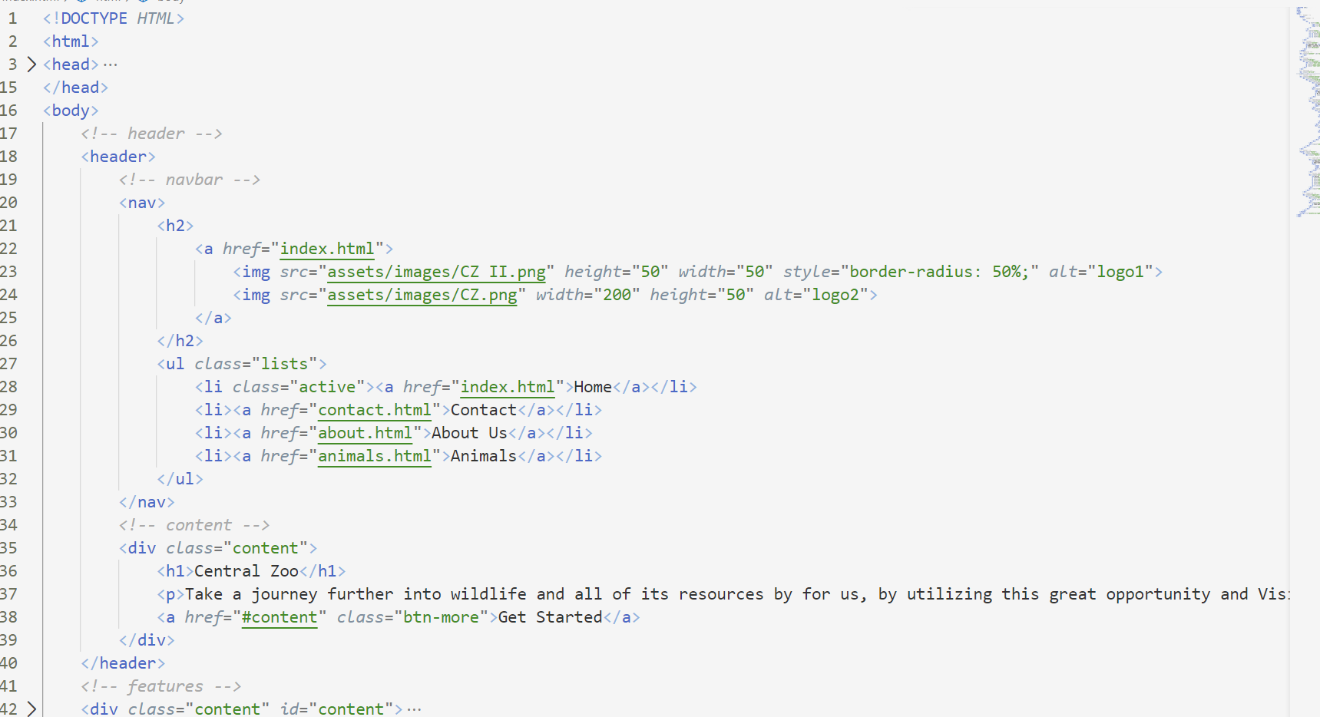

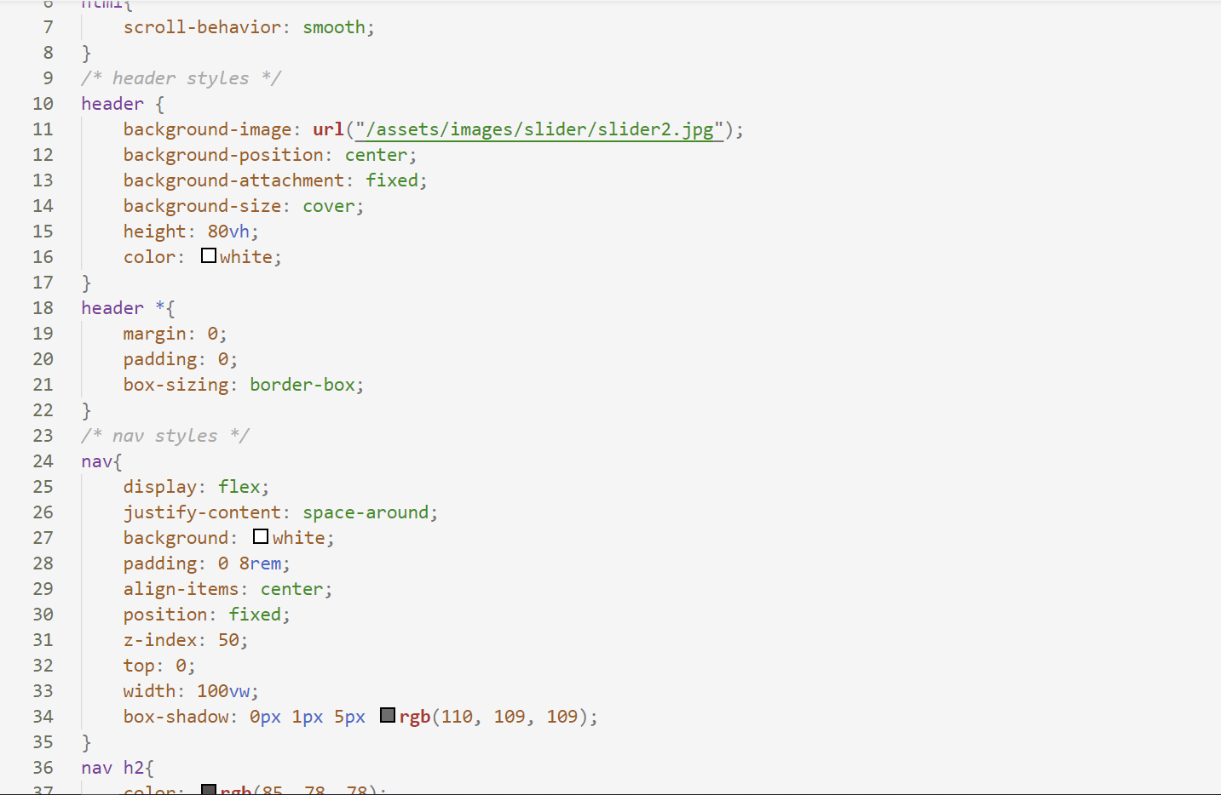

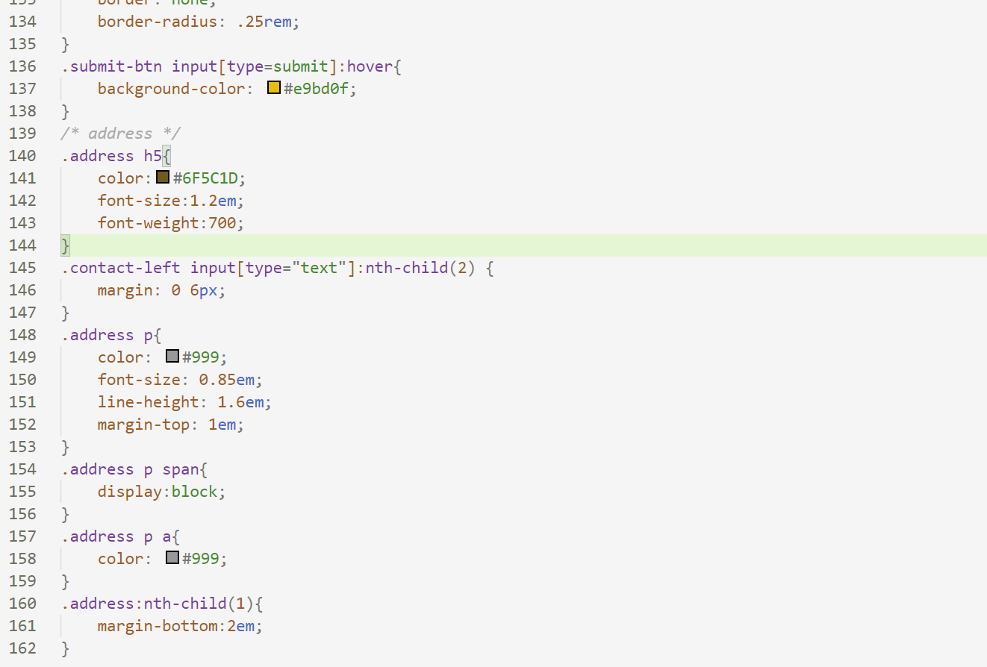

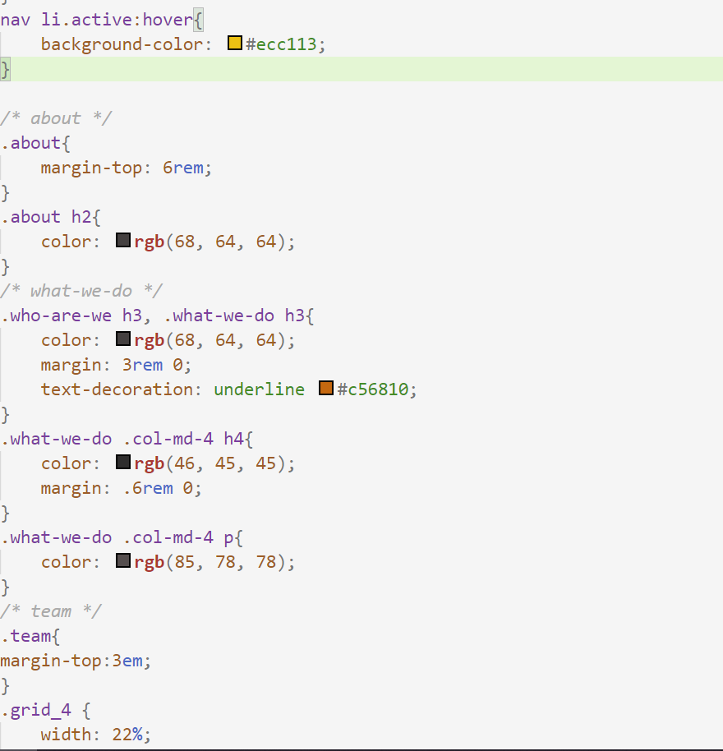

**User Guide**

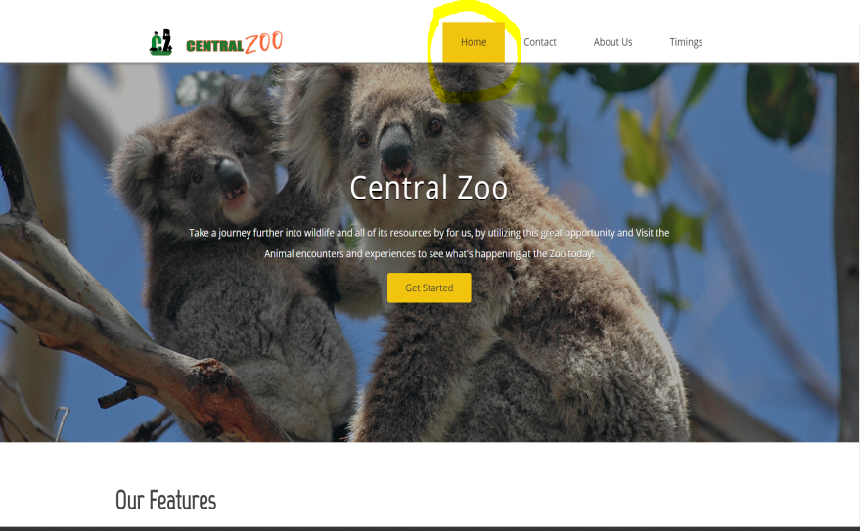

**Your personal homepage**

Once you are the home page,

You can go to other pages using the

Navigation bar or if you not on the home, use the navigation bar to get to home page.

At the center of picture, you will

See a get started button and as you

Click on the button, the page scrolls to

The “Our Features section.

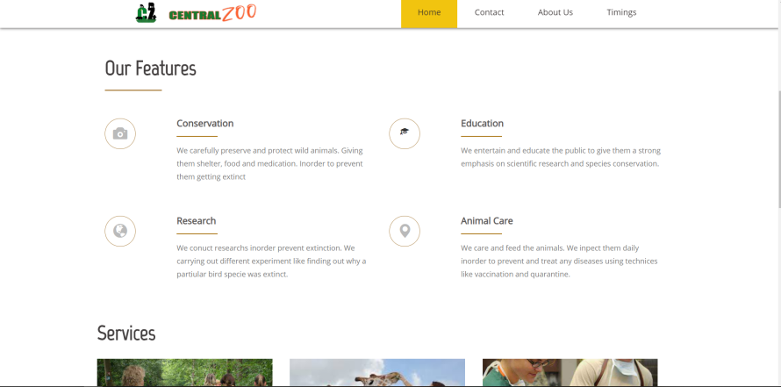**Our Features section**

On the features section, we just

talked about what makes us the best and how we provide the best solutions.

**Services section**

On the features section, we just

talked about what we often as a service. You can read them, if you want to.

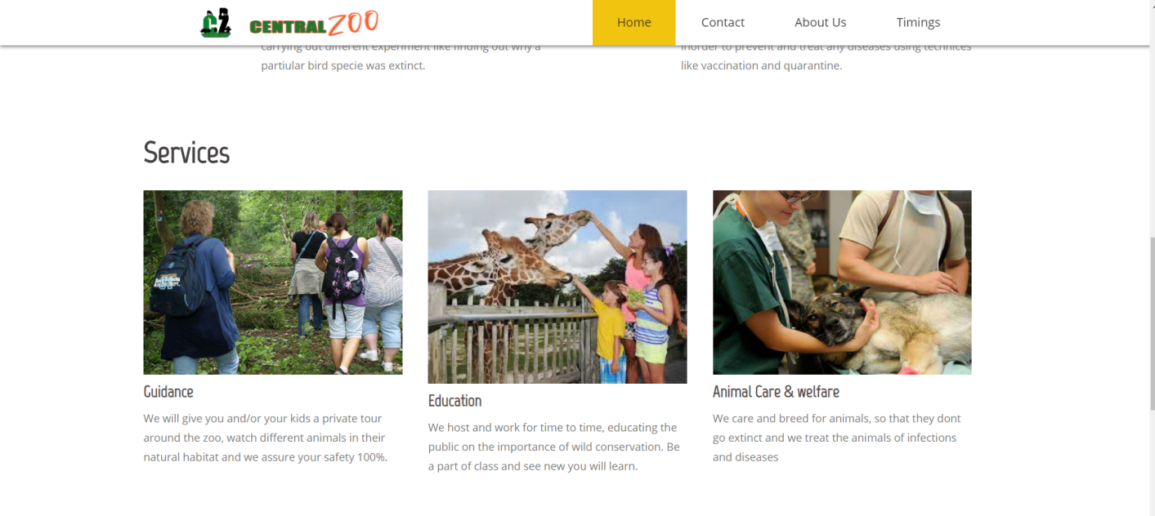

**Latest News and Testimonials**

In this section, we display the latest news and testimonials from users.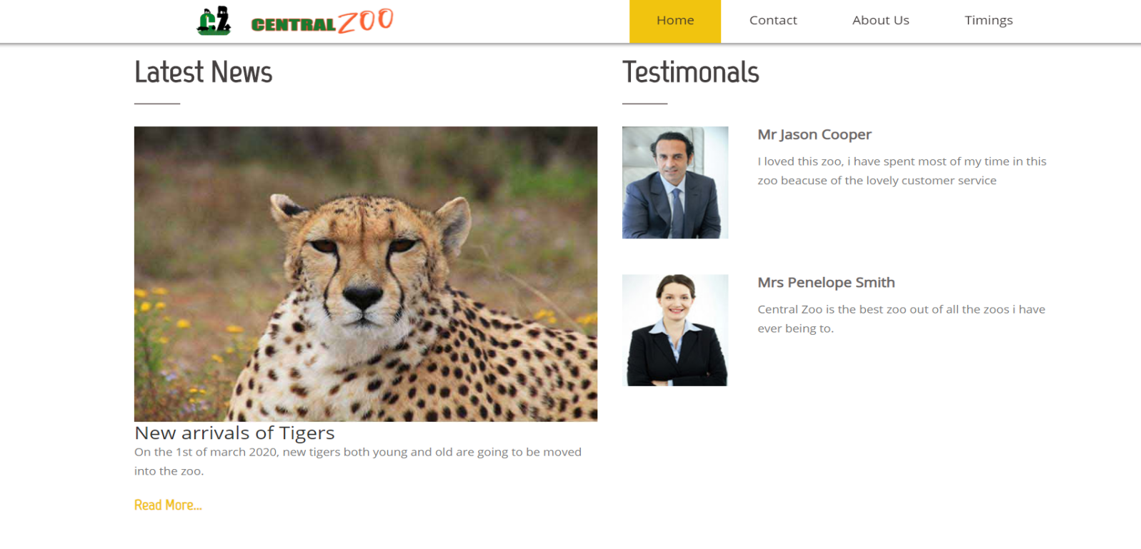**Contact Us Page**

To get to the contact page, go to the navigation bar and click on the Contact link.

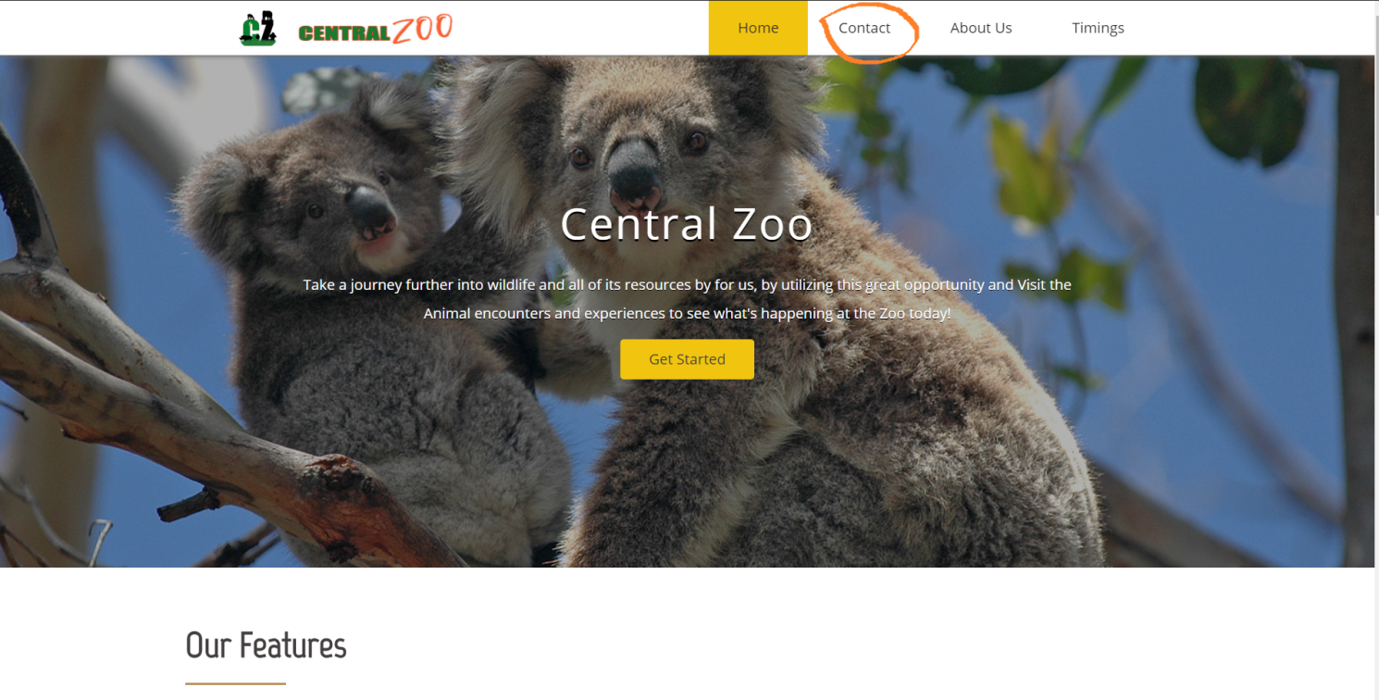

Once you get to the contact page, you will see a map of our exact location, our address, phone no and contact form, you can use any of the convenient options to reach out to us.

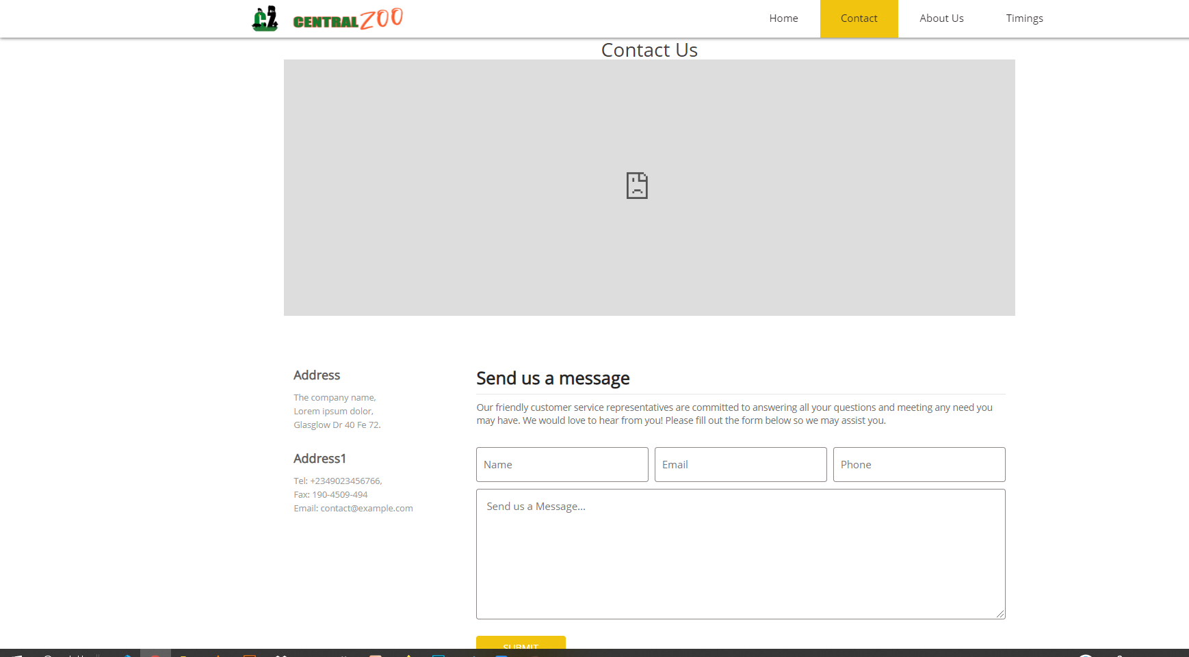

**About Page**

To get to the About page, go to the navigation bar and click on the About link.

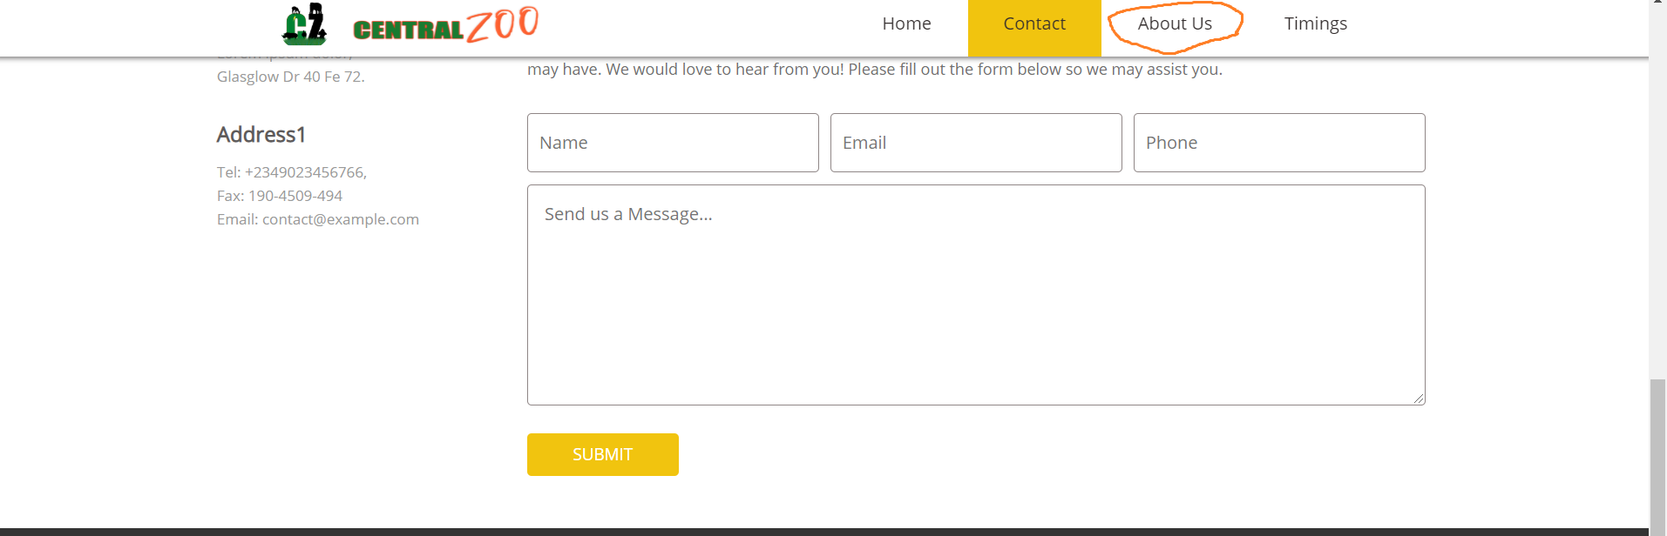

Once you get to the About page, you will see more info about us such as our team and what we do.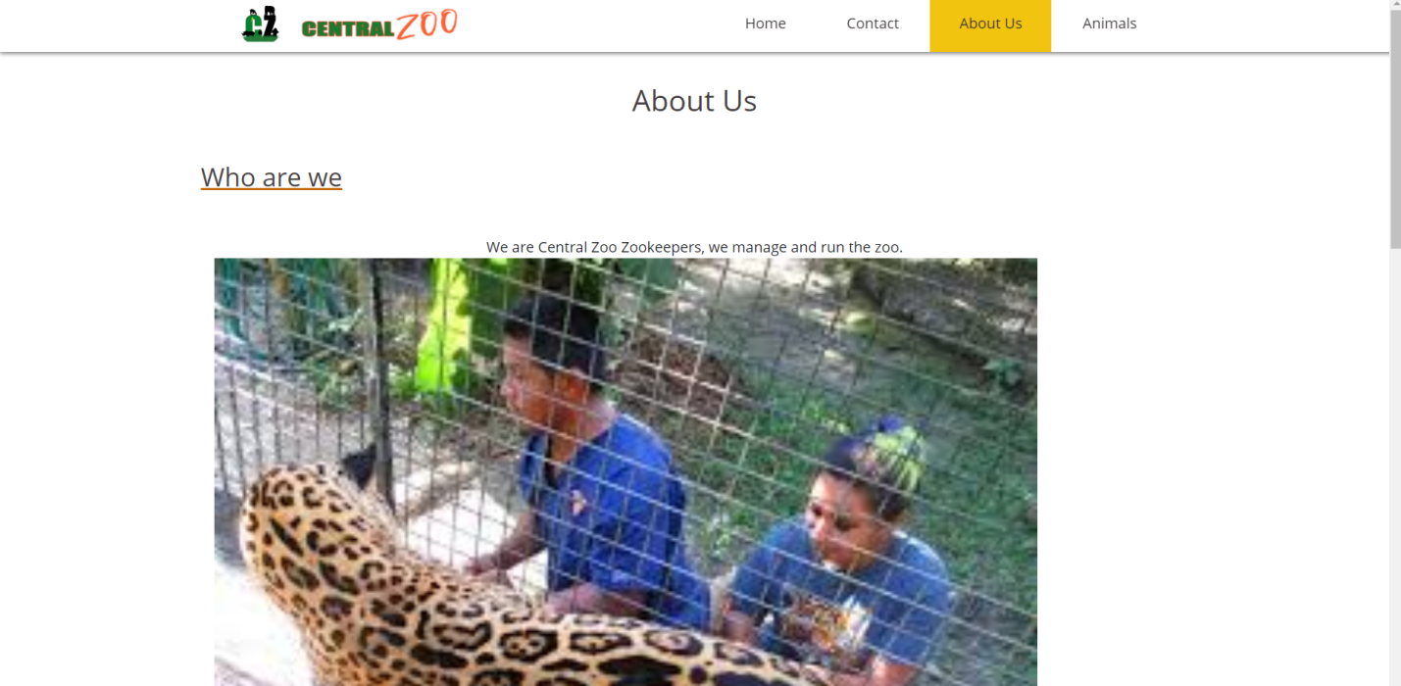

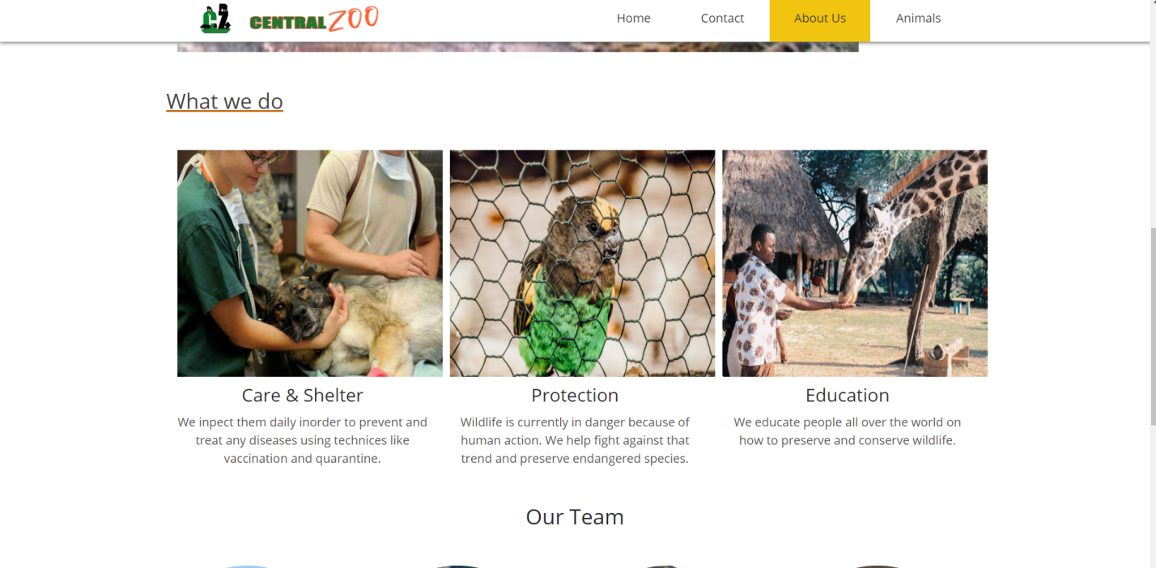

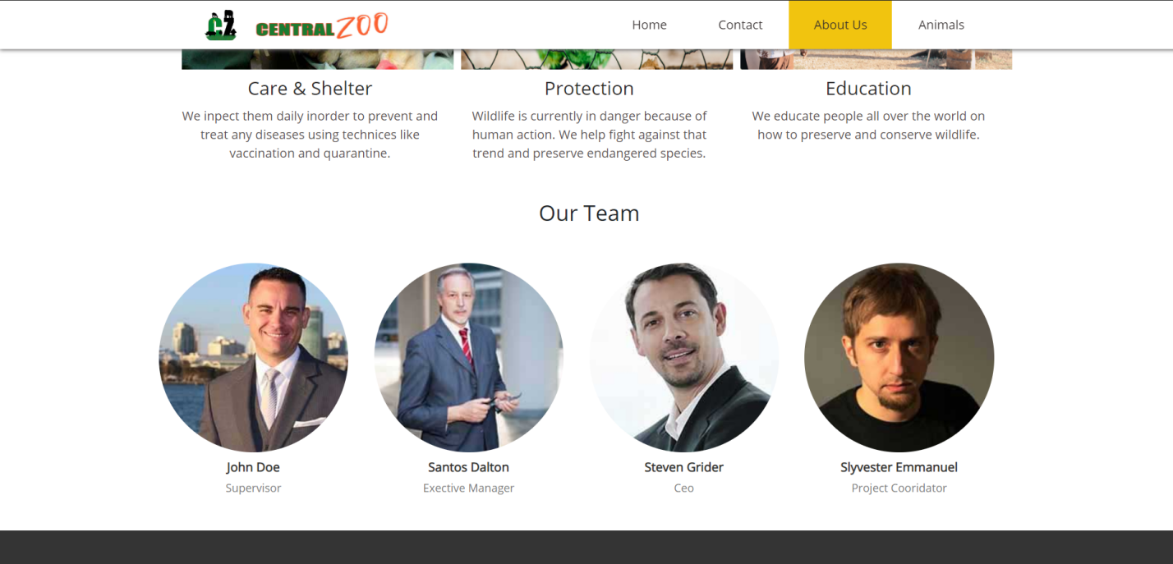

**Feedback and Query**

To get to the feedback page, go to the footer bar at the end of any page and click on the send a feedback.

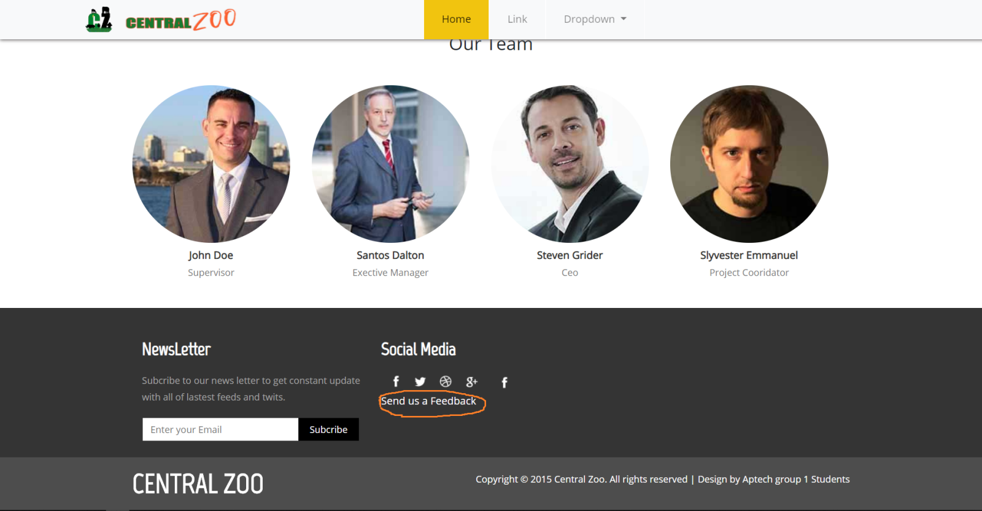

On the feed back page, you will see a feed back form, then give us your feedback.

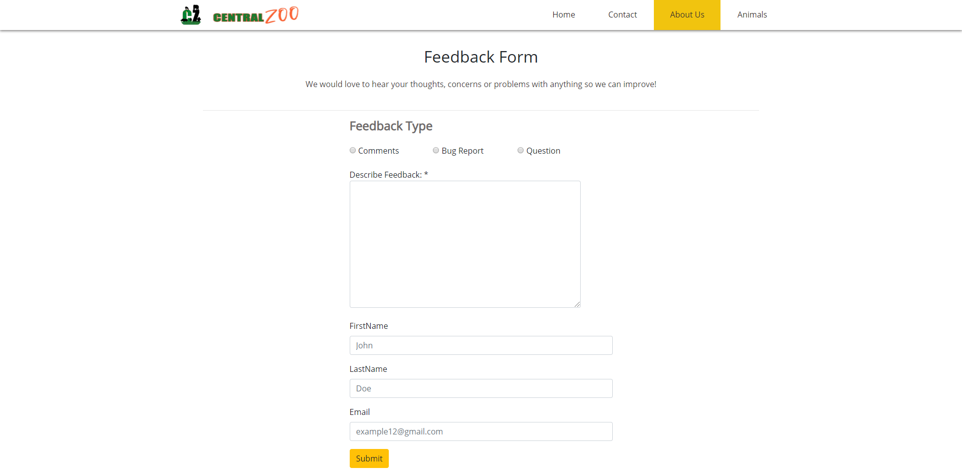

**Animals**

To get to the Animals page, go to the navigation bar and click on the Animals link.

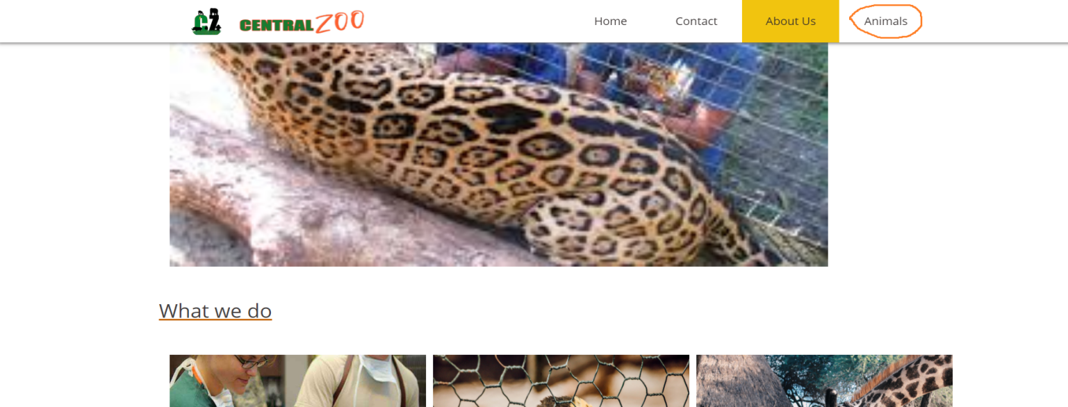

On the animals page, we talked a lot about animals like birds and land animals. And also there two galleries on page. The first is for animals and the other for birds.

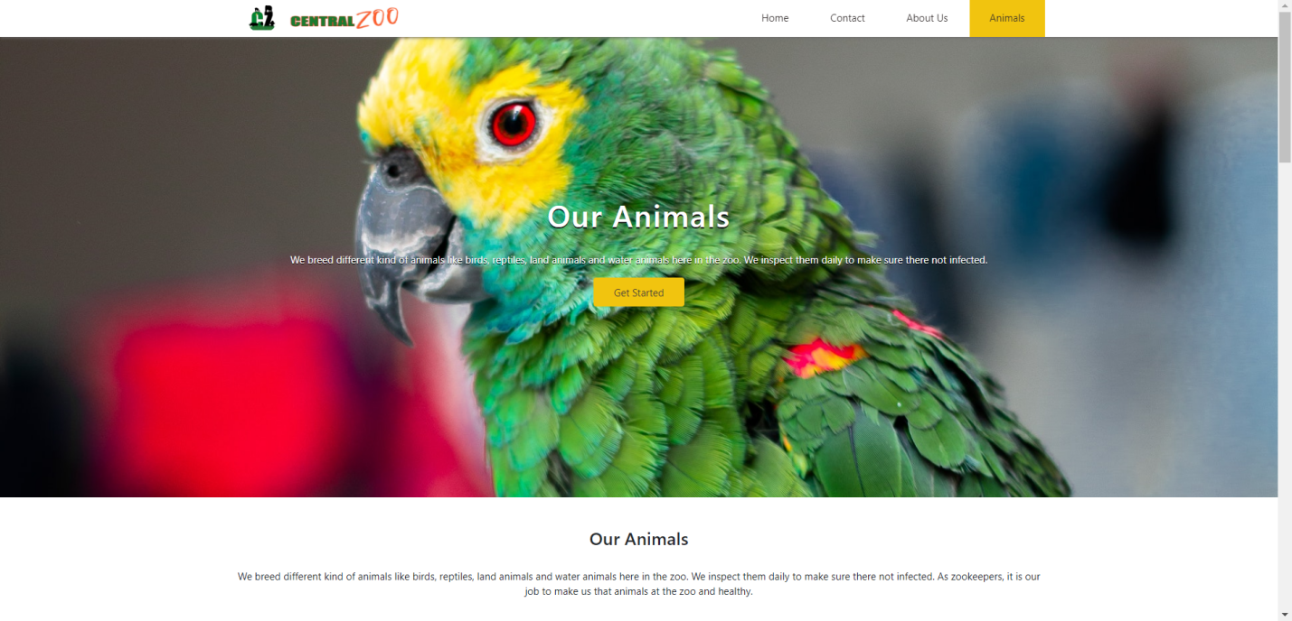

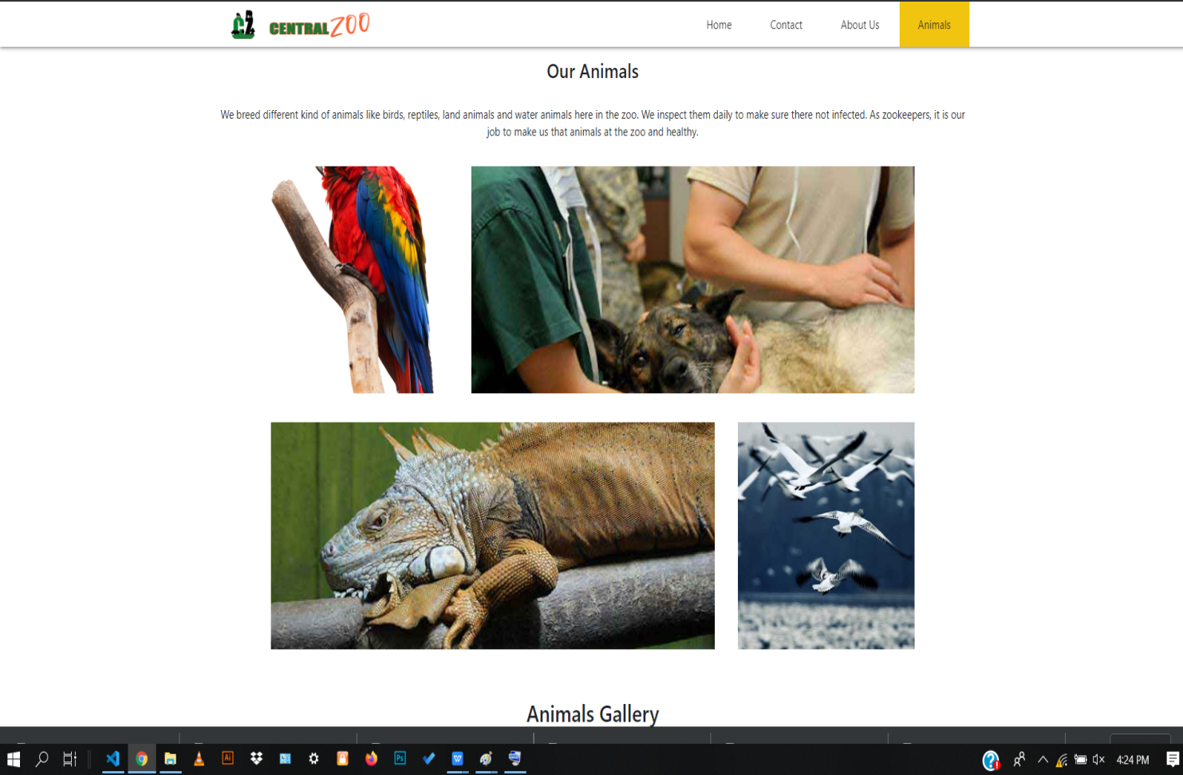

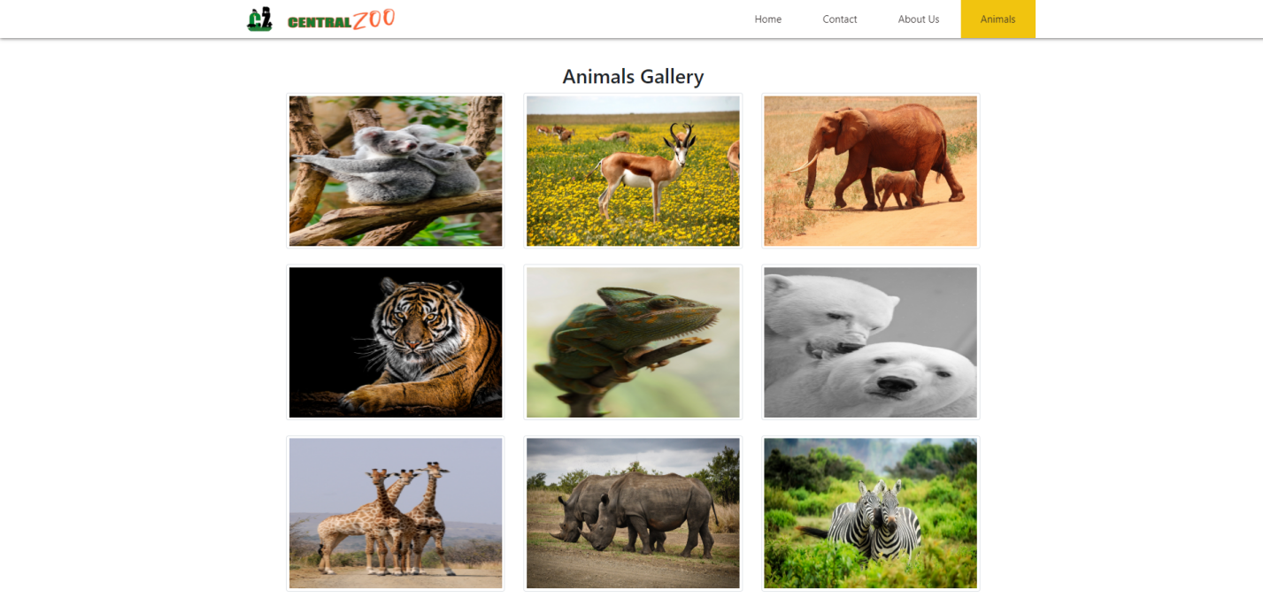

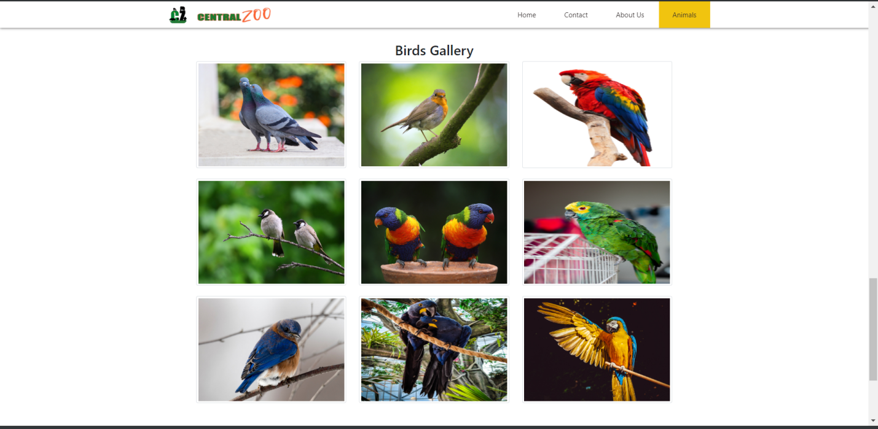

**Developer’s Guide**

The following project contains five html files(index, about, animals, feedback, contact) and a directory called assets. The assets directory contains sub-directories namely css, Font-Awesome-master, font, font2, images, js, lightbox2-2.11.1.

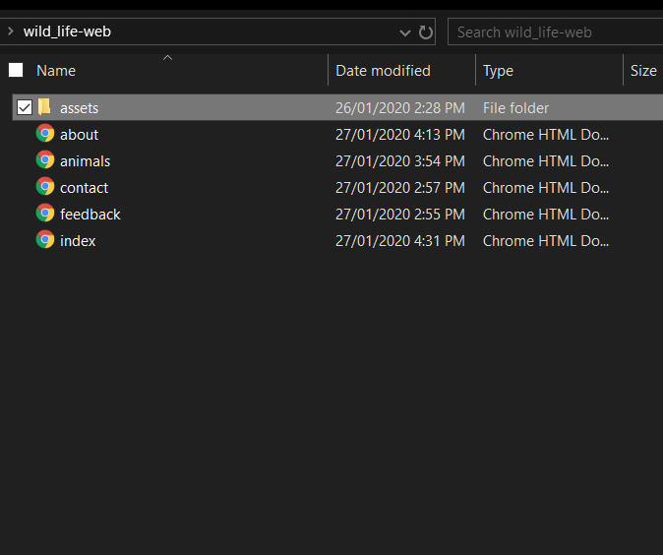

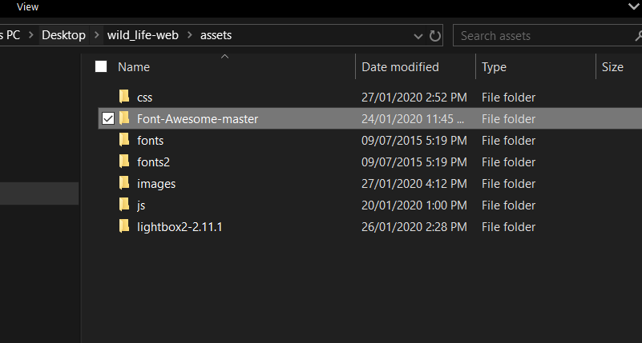

The css sub-directory contains css files for each page and other css libraries(bootstrap, lightbox).

The Font-Awesome-master sub-directory contains file for font-awesome library used in this project. This directory must not be deleted or tampered with.

The font and font2 sub-directory contains file for the fonts used in this project. This directory must not be deleted or tampered with.

The images sub-directory contains all the images used in this project.

The js sub-directory contains all the javascript files used in this project.

The lightbox2-2.11.1 sub-directory contains files for the lightbox library used in this project. This directory must not be deleted or tampered with.